# File permissions in Linux

## Project description

This project is to demonstrate knowledge and skills towards examining and managing file permissions. Linux commands within the Bash shell will be used to accomplish this project.

Scenario background: As a security analyst, setting appropriate access permissions is critical to protecting sensitive information and maintaining the overall security of a system.

## Check file and directory details

In this task, you must explore the permissions of the projects directory and the files it contains. The lab starts with /home/researcher2 as the current working directory. This is because you're changing permissions for files and directories belonging to the researcher2 user.

The permissions of the files in the projects directory are as follows:

Navigate to projects directory= cd projects

Check file and directory permissions= ls -l

## Describe the permissions string

 A directory with full permissions for all owner types would be drwxrwxrwx:

* The 1st character indicates the file type. The d indicates it’s a directory. When this character is a hyphen (-), it's a regular file.
* The 2nd-4th characters indicate the read (r), write (w), and execute (x) permissions for the user. When one of these characters is a hyphen (-) instead, it indicates that this permission is not granted to the user.
* The 5th-7th characters indicate the read (r), write (w), and execute (x) permissions for the group. When one of these characters is a hyphen (-) instead, it indicates that this permission is not granted for the group.
* The 8th-10th characters indicate the read (r), write (w), and execute (x) permissions for the owner type of other. This owner type consists of all other users on the system apart from the user and the group. When one of these characters is a hyphen (-) instead, that indicates that this permission is not granted for other.

The second block of text in the expanded directory listing is the user who owns the file. The third block of text is the group owner of the file.

## Change file permissions

Check whether any files in the projects directory have write permissions for the owner type of other:

Check permissions of files and directories= ls -l

Check permissions of files and directories to include hidden files= ls -la

Change permission on the file project_k.txt so that the owner type of other doesn’t have write permissions= chmod o-w project_k.txt

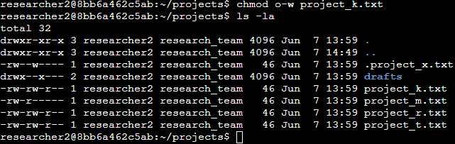

## Change file permissions on a hidden file

## The file .project_x.txt is a hidden file that has been archived and should not be written to by anyone. (The user and group should still be able to read this file.)

Change the permissions of the file .project_x.txt so that both the user and the group can read, but not write to, the file= chmod u-w, g-w .project_x.txt

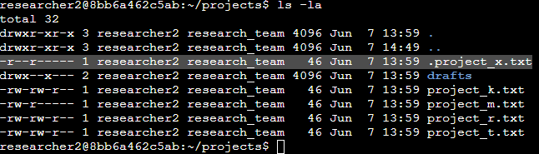

## Change directory permissions

## Change the permissions of a directory. First, you’ll check the group permissions of the /home/researcher2/projects/drafts directory and then modify the permissions as required.

Navigate to the drafts directory=cd drafts

Only the researcher2 user should be allowed to access the drafts directory and its contents. (This means that only researcher2 should have execute privileges.)

Remove the execute permission for the group from the drafts directory= chmod g-x drafts

## Summary

In this activity I checked the file and directory details for all files within the project directory using the ls- l and ls- la commands. I then changed permissions on the file project_k.txt so that the owner type of other doesn’t have write permissions using the command chmod o-w project_k.txt. Finally, I changed the permissions for the directory drafts using the command chmod g-x drafts.